1] Create Workplace
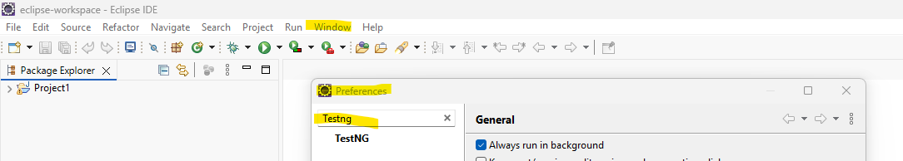

2] Create a Java project
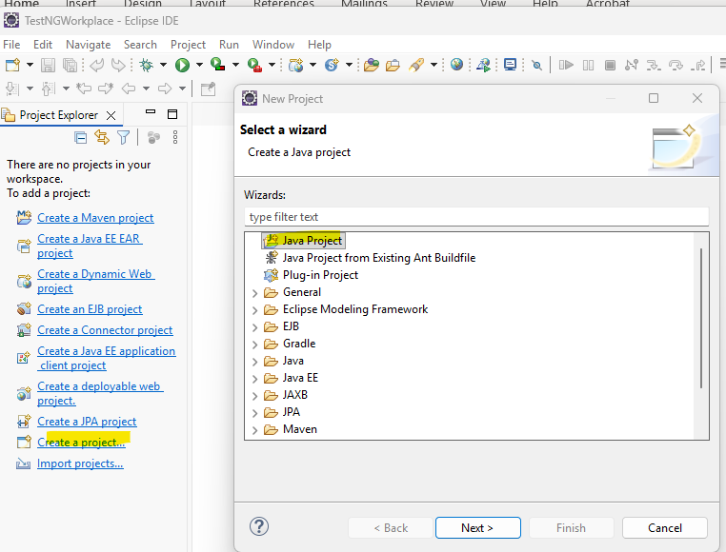

3]Add jars
write click on JRE->configure Build Path=> Build Path=>Libraries=>Class path=>Add External Jar Files ->select Selenium Jar Files -> Apply & Close
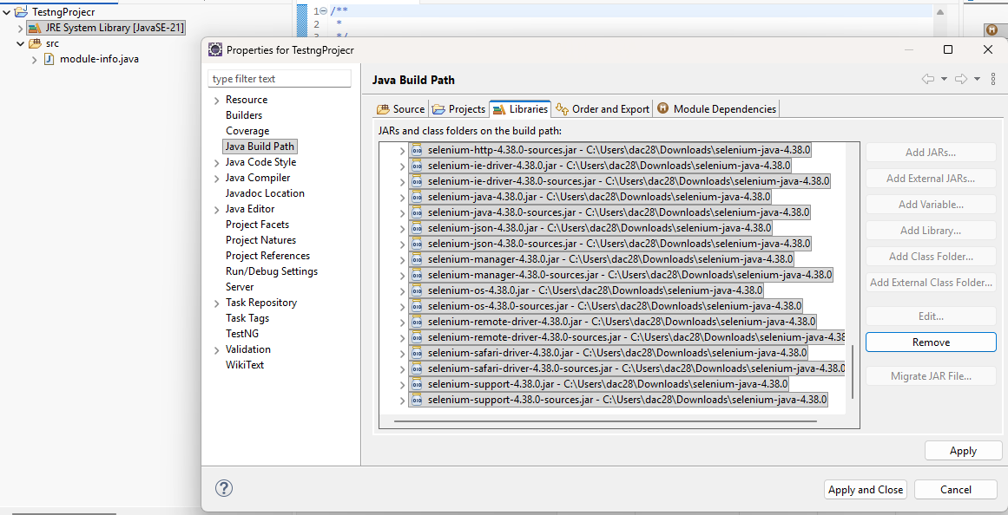

4] Create TestNG
Write click on src folder=>TestNG=> Create TestNG class
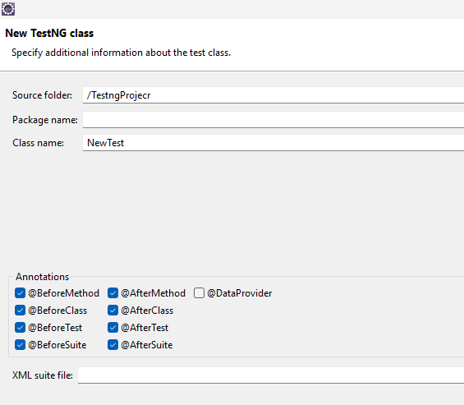

5]if error occurs Also Add Test NG
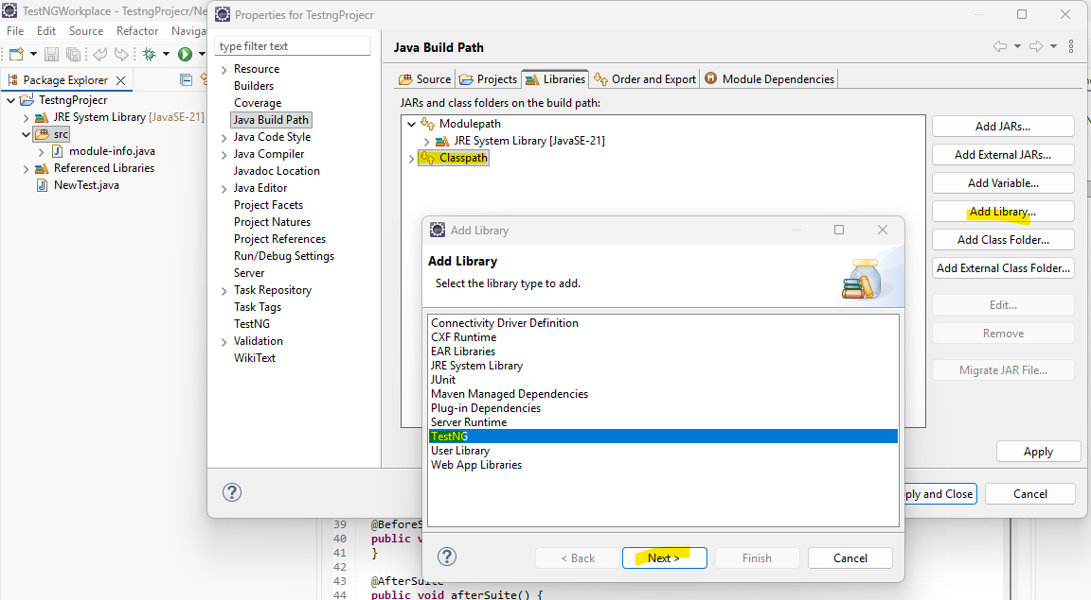

Default Annotation is
public class NewTest {
@Test // Default Annotation
public void f() // By default class name is f()
{
}

6]Sequences of Annotations
Check file in src folder =>
NewTest=> write click in file-> Run as TestNG Test
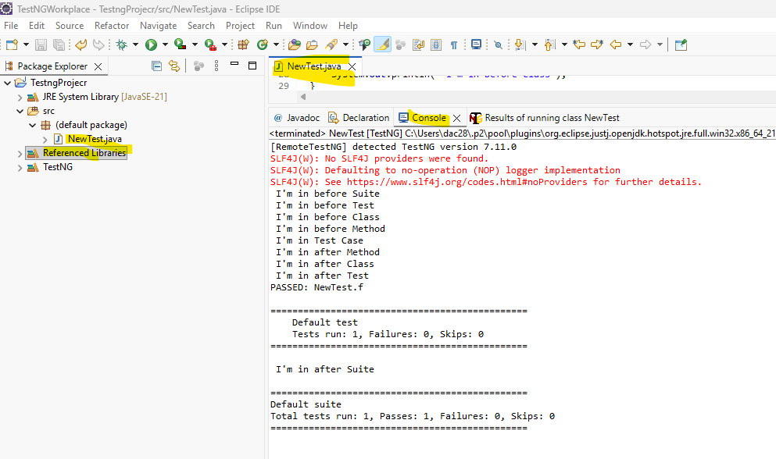

7]refresh the ptoject
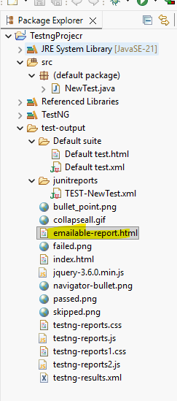
Open wth Browser selected file
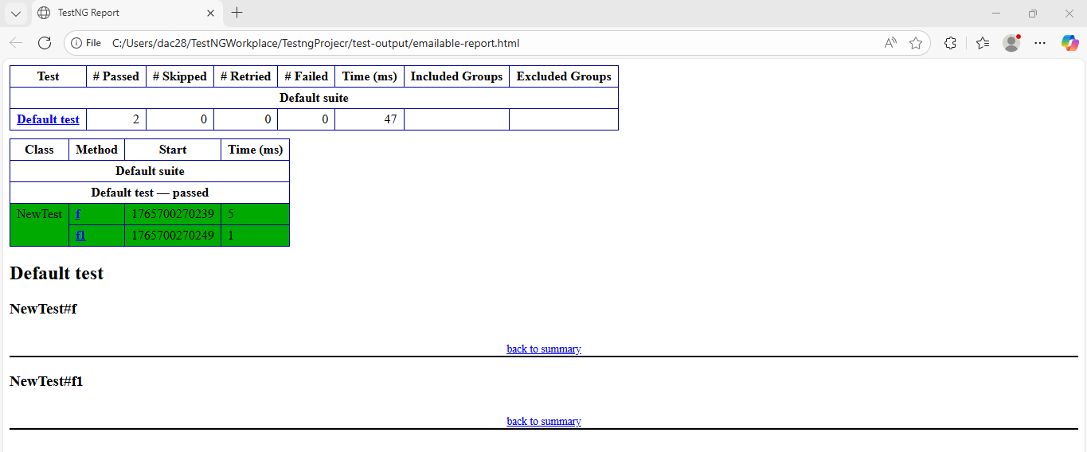

8]Newtest.java
import org.testng.annotations.Test;
import org.testng.annotations.BeforeMethod;
import org.testng.annotations.AfterMethod;
import org.testng.annotations.BeforeClass;
import org.testng.annotations.AfterClass;
import org.testng.annotations.BeforeTest;
import org.testng.annotations.AfterTest;
import org.testng.annotations.BeforeSuite;
import org.testng.annotations.AfterSuite;

public class NewTest {
@Test
public void f() {
System.out.println(" I'm in Test Case");
}
@BeforeMethod
public void beforeMethod() {
System.out.println(" I'm in before Method");
}

@AfterMethod
public void afterMethod() {
System.out.println(" I'm in after Method");
}

@BeforeClass
public void beforeClass() {
System.out.println(" I'm in before Class");
}

@AfterClass
public void afterClass() {
System.out.println(" I'm in after Class");
}

@BeforeTest
public void beforeTest() {
System.out.println(" I'm in before Test");
}

@AfterTest
public void afterTest() {
System.out.println(" I'm in after Test");
}

@BeforeSuite
public void beforeSuite() {
System.out.println(" I'm in before Suite");
}

@AfterSuite
public void afterSuite() {
System.out.println(" I'm in after Suite");
}

@Test
public void f1() {
System.out.println(" I'm in Test Case1");
}
@BeforeMethod
public void beforeMethod1() {
System.out.println(" I'm in before Method1");
}

@AfterMethod
public void afterMethod1() {
System.out.println(" I'm in after Method1");
}

@BeforeClass
public void beforeClass1() {
System.out.println(" I'm in before Class1");
}

@AfterClass
public void afterClass1() {
System.out.println(" I'm in after Class1");
}

@BeforeTest
public void beforeTest1() {
System.out.println(" I'm in before Test1");
}

@AfterTest
public void afterTest1() {
System.out.println(" I'm in after Test1");
}

@BeforeSuite
public void beforeSuite1() {
System.out.println(" I'm in before Suite1");
}

@AfterSuite
public void afterSuite1() {
System.out.println(" I'm in after Suite1");
}

}

9]Output
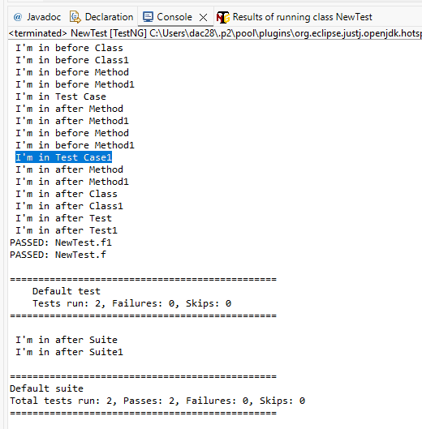

1] OpenBrowser.ava -> login only
import org.openqa.selenium.By;
import org.openqa.selenium.WebDriver;
import org.openqa.selenium.chrome.ChromeDriver;
import org.testng.annotations.AfterTest;
import org.testng.annotations.BeforeTest;
import org.testng.annotations.Test;

public class OpenBrowser {

WebDriver wd;

@BeforeTest
public void beforeTest() throws InterruptedException {
wd = new ChromeDriver();
wd.manage().window().maximize();
wd.get("https://practicetestautomation.com/practice-test-login/");
Thread.sleep(2000);
}

@Test
public void f() throws InterruptedException {
wd.findElement(By.name("username")).sendKeys("student");
wd.findElement(By.name("password")).sendKeys("Password123");
wd.findElement(By.id("submit")).click();
Thread.sleep(2000);
}

@AfterTest
public void afterTest() {
wd.quit();
}
}

2] Output:-
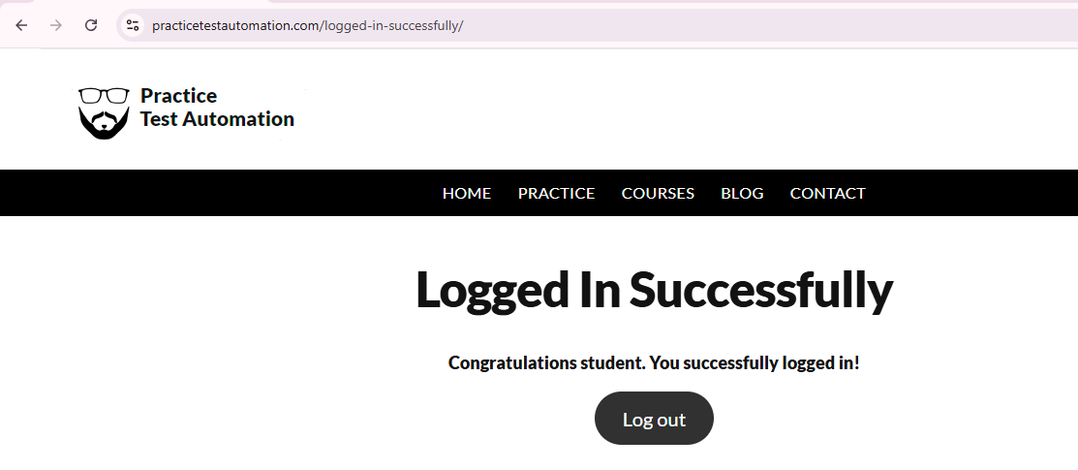

1]MoveTest.java
import org.testng.annotations.Test;
import org.testng.SkipException;
public class MoveTest {
// 4 Test scripts
//@Test(priority=1, enabled=false)
@Test(priority=1)
public void register() {
throw new SkipException("Not Completed");
//System.out.println("Register Test Script");
}
@Test(priority=2)
public void login() {
System.out.println("Login Test Script");
}
@Test(priority=3)
public void home() {
System.out.println("Home Test Script");
}
@Test(priority=4)
public void logout() {
System.out.println("Logout Test Script");
}
// @Test(priority=5)
// public void a() {
// System.out.println("a Test Script");
// }

}
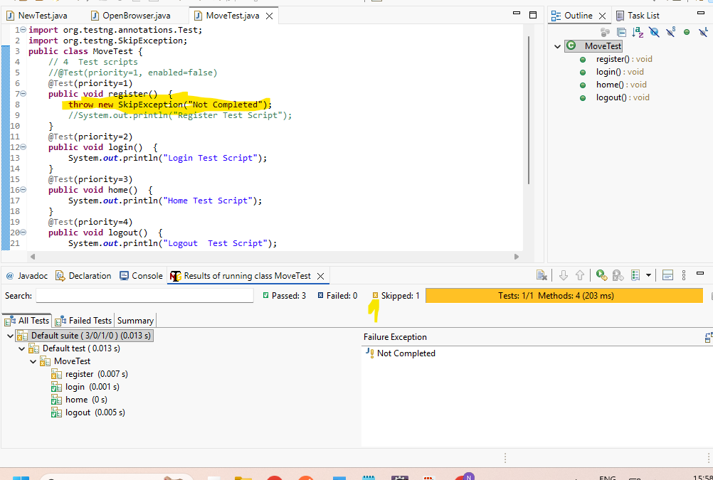

2] Output:- 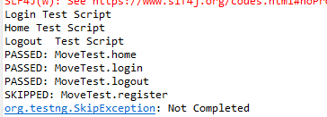

1] Test NG :- This file will run all classes in one click
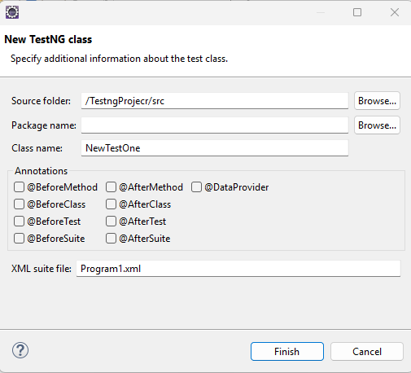
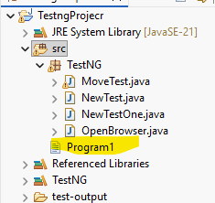
1] Program1<?xml version="1.0" encoding="UTF-8"?>
<suite parallel="false" name="Suite">
<test name="Test">
<classes>
<class name="TestNG.MoveTest"/>
<class name="TestNG.NewTest"/>
<class name="TestNG.NewTestOne"/>
<class name="TestNG.OpenBrowser"/>
</classes>
</test> <!-- Test -->
</suite> <!-- Suite -->

2] Output:- all 4 files will run in sequence

1]Input.properties
un=student
pw=Password123

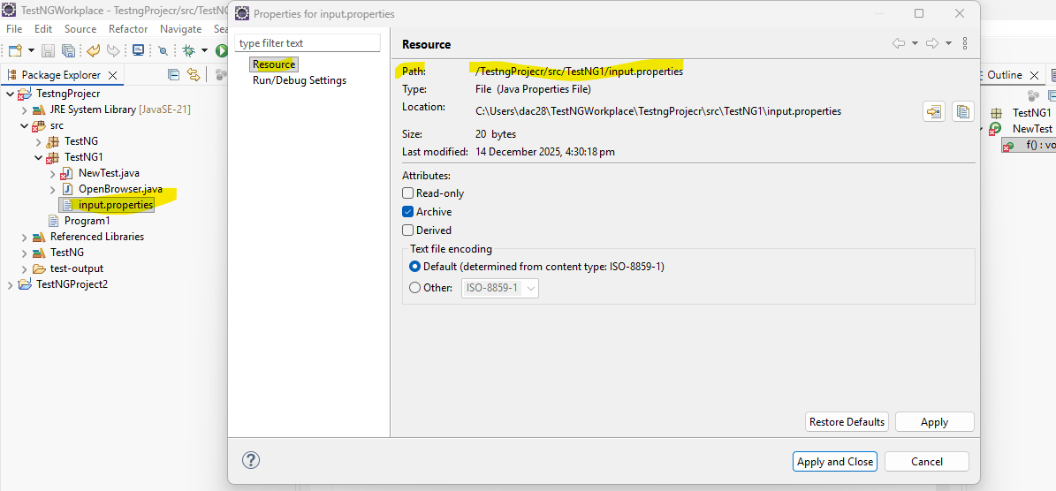

2]NewTest.java
package TestNG1;
import org.openqa.selenium.By;
import org.openqa.selenium.WebDriver;
import org.openqa.selenium.chrome.ChromeDriver;
import org.testng.annotations.Test;

import java.io.FileInputStream;
import java.io.IOException;
import java.util.Properties;

public class NewTest {

@Test
public void f() throws IOException, InterruptedException {

WebDriver d = new ChromeDriver();

d.get("https://practicetestautomation.com/practice-test-login/");

Properties p = new Properties();
FileInputStream fs = new FileInputStream(
"src/TestNG1/input.properties"
);
p.load(fs);

d.findElement(By.name("username"))
.sendKeys(p.getProperty("un"));

d.findElement(By.name("password"))
.sendKeys(p.getProperty("pw"));

d.findElement(By.id("submit")).click();

Thread.sleep(2000);
}
}

3]OpenBrowser.java
package TestNG1;

import java.io.FileInputStream;
import java.io.IOException;
import java.util.Properties;

import org.openqa.selenium.By;
import org.openqa.selenium.WebDriver;
import org.openqa.selenium.chrome.ChromeDriver;
import org.testng.annotations.AfterTest;
import org.testng.annotations.BeforeTest;
import org.testng.annotations.Test;

public class OpenBrowser {

WebDriver wd;

@BeforeTest
public void beforeTest() throws InterruptedException {
wd = new ChromeDriver();
wd.manage().window().maximize();
wd.get("https://practicetestautomation.com/practice-test-login/");
Thread.sleep(6000);
}

@Test
public void f() throws IOException, InterruptedException {

Properties p = new Properties();
FileInputStream fs = new FileInputStream(
"src/TestNG1/input.properties"
);
p.load(fs);

wd.findElement(By.name("username"))
.sendKeys(p.getProperty("un"));

wd.findElement(By.name("password"))
.sendKeys(p.getProperty("pw"));

wd.findElement(By.id("submit")).click();

Thread.sleep(2000);
}

@AfterTest
public void afterTest() {
wd.quit();
}
}

2] Output:-

